How to draw velocity diagrams

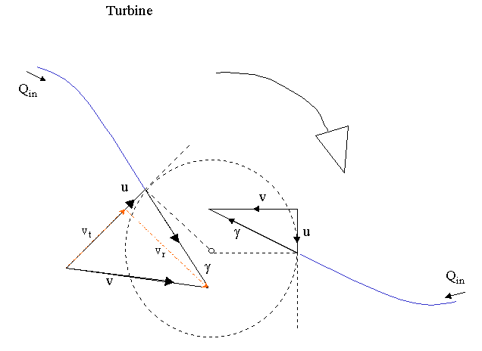

1. identify 1 point (the tip of the blade)
[this point actually lies on circumference of a "imaginary" circle]

2. draw the tangent & radius for this point (dotted line)

3. to draw relative velocity (of fluid wrt blade)
a) we must know whether water is flowing towards tip of blade OR away from it
b) we also understand that
the blade (at point of exit) is parallel to the relative velocity at this point
[the point of exit is of course the tip of the blade]
[the relative velocity used here is always velocity of fluid (V) with respect to the blade velocity (U)]

therefore draw the +ve dir. of γ (relative velocity of fluid with respect to blade)

For turbine, exit is at inner circle & entry at outer circle
(at exit, draw γ from tip of blade into circle & if V_{t} = 0 then γ points into centre of circle)
(at entry, draw γ pointing at tip of blade)

4. to draw absolute blade velocity (U)
- we must know whether runner (the whole cascade of blades) is turning clockwise or anti-clockwise
this determines the direction of +ve U
- we also understand that U is parallel to the tangent of circle (at tip of blade)

from the vector γ, we try to create the vector ( U + γ ) [ γ = V - U => γ + U = V ]
(my preference is to draw U+γ rather than γ+U but there will both give correct diagrams)
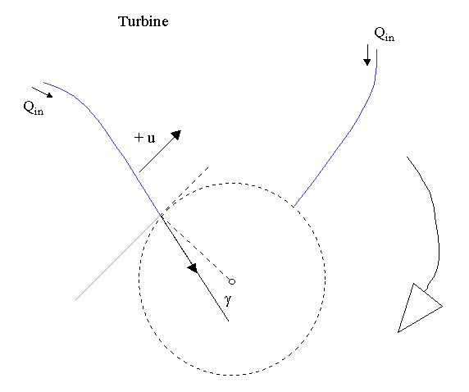

5. knowing γ = V - U, draw V and its direction

6. check direction arrow of U (you know runner is turning clockwise OR anti-clockwise)

7. check direction arrow of γ (you know whether water is flowing towards blade OR away from blade)

8. check that γ = V - U or γ + U = V
