Contents

S/N | Topic | Page
1 | Abstract | 2
2 | Introduction | 2
3 | Mix Design Calculation | 3
4 | Workability Test Results | 8
5 | Compressive Strength Test Results | 8
6 | Discussion of Tests Results | 9
6 | Estimation of the 7-Day Strength | 10
7 | Comparison of Estimated and Actual 7-Day Strength | 11
8 | Estimation of the 28-Day Strength | 12
9 | Comments on Characteristic Strength of Trial Mix | 12
10 | Test Adjustments | 14
11 | Conclusion | 16
12 | References | 16
13 | Appendix | 17
Abstract

In the testing of a trial mix, batch quantity calculations have been made to derive the concrete mix design for a desired compressive strength and degree of workability. Concrete cubes are then mixed and cast based on these batch quantities. Workability is tested at this stage and checked against the assigned value. Then, from the strength tests conducted on the first, third and seventh day, the 28-day strength is deduced from further calculations. This value is then compared with the initial intended compressive strength.

Such testing of a trial mix creates awareness in the considerations in the preparation of an appropriate concrete mix, and also exposes the real-life difficulties and discrepancies from the making to the derivation of the final trial product.

Introduction

The two major requirements for a concrete mix are its compressive strength and its degree of workability. The trial mix is thus designed according to some assigned values of compressive strength and workability.

Based on the British practice known as the DOE (Department of the Environment) method, a trial mix is prepared using the calculated mix design batch quantities. The workability of the mix is measured when the concrete is still fresh, using the slump test and the compaction test. Then, concrete cubes are cast from the mix and these cubes are cured every day for a period of 7 days. The compressive strength of the cubes is then tested on the first, third and seventh day when the concrete has hardened. Two concrete cubes are tested each day and a mean value is obtained. Finally, these values of workability and strength are compared with the initial design values.

From the design and the hands-on mixing experience, civil engineering students may gain practical knowledge in the making of concrete, and also become exposed to the possible difficulties and discrepancies in its making.
Mix Design Calculations

Requirements : f_{cu} = 35 MPa; Slump = (150  25) mm

Assumptions : 5% defective; k = 1.64; s = 3 MPa
Margin : 1.64  3 = 5 MPa
Target Mean Strength : 35 + 5 = 40 MPa
Cement Type : OPC Density = 3100 kg/m³
Fine Aggregate : Uncrushed Density = 2650 kg/m³
Coarse Aggregate : Crushed Density = 2650 kg/m³
WRA : Daratard 88
Dosage of WRA : 500ml per 100 kg of cement
Water Reduction : 12%
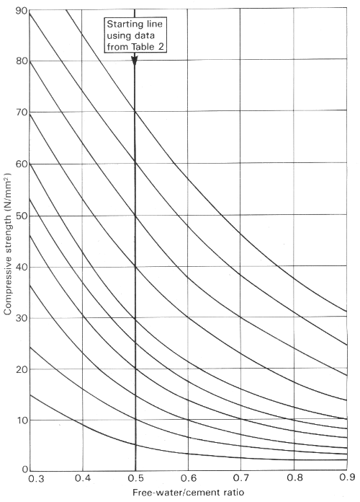
For sand, 40% passing through 600 m sieve.
Figure 1. Relation between Compressive Strength and Free-Water / Cement Ratio for use in the British Mix Selection Method

Maximum Aggregate Size : 20 mm
From Figure 1,
Free Water / Cement Ratio : 0.6

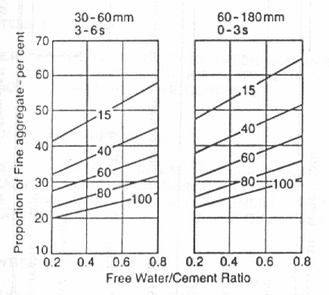
Figure 2. Recommended proportion of Fine Aggregate (expressed as a percentage of total aggregate) as a function of Free-Water / Cement Ratio for various Workabilities and Maximum Sizes (numbers refer to percentage of fine aggregate passing 600 m sieve)

From Figure 2,
Proportion of Fine Aggregate : 47%

For slump of 150 mm,

Aggregate | Water content (kg/ m³) for:
Max size (mm) | Type | Slump (mm) | 1-10 | 10-30 | 30-60 | 60-180
Max size (mm) | Type | Vebe time (s) | >12 | 6-12 | 3-6 | 0-3
10 | Uncrushed |  | 150 | 180 | 205 | 225
10 | Crushed |  | 180 | 205 | 230 | 250
20 | Uncrushed |  | 135 | 160 | 180 | 195
20 | Crushed |  | 170 | 190 | 210 | 225
40 | Uncrushed |  | 115 | 140 | 160 | 175
40 | Crushed |  | 155 | 175 | 190 | 205
Figure 3. Approximate Free Water Content required to give various levels of Workability according to 1988 British Method

From Figure 3,
W_{f} = 195 kg/m³; W_{c} = 225 kg/m³

Since Free-Water Content is estimated by the expression,
Water content = $\frac{2}{3}W_{f}+\frac{1}{3}W_{c}$
where W_{f} = free-water content appropriate to type of fine aggregate
and W_{c} = free-water content appropriate to type of coarse aggregate

⇒ Estimated Water content = $\frac{2}{3}(\text{195})+\frac{1}{3}(\text{225})$ = 205 kg/m³
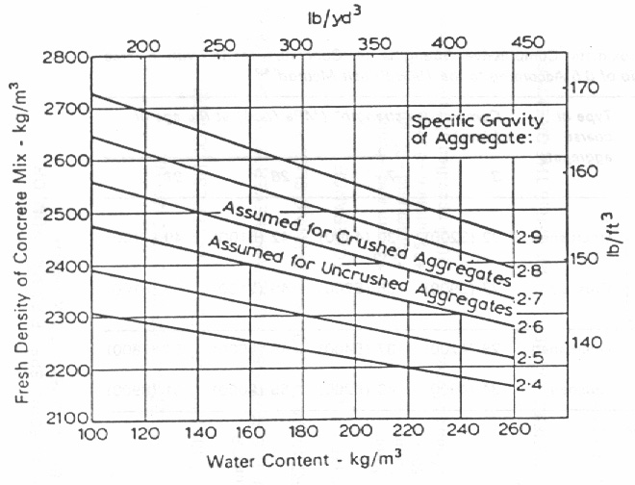
Figure 4. Estimated Wet Density for Fully Compacted Concrete

From Figure 4,
Fresh Density of Mix = 2400 kg/m³
Cement content = 205  0.6 = 341.6 = 340 kg/m³
Total aggregate content = 2400 – 205 – 340 = 1855 kg/m³
Fine aggregate content = 1855  47% = 870 kg/m³
Coarse aggregate content = 1855 – 870 = 985 kg/m³
Mix proportion:
Cement : Fine Aggr : Coarse Aggr : Water
= 340 : 870 : 985 : 205

With WRA,
New water content = 205  88% = 180.4 = 180 kg/m³
New cement content = 180  0.6 = 300 kg/m³
Water reduction = 205 – 180 = 25 kg/m³
Cement reduction = 340 – 300 = 40 kg/m³

Reduction of volume
Of water = 25  1000 = 0.025 m³
Of cement = 40  3100 = 0.0129 m³
Total reduction = 0.0379 m³

Increase in Aggregates
Increase in Fine Aggr = 0.0379  2650 = 100 kg/m³
⇒ Total Fine Aggr = 870 + 100 = 970 kg/m³
Increase in Coarse Aggr = 100 kg/m³
⇒ Total Coarse Aggr = 985 + 100 = 1085 kg/m³
Proportion = 0.47 : 0.53 = 47 : 52 = 45 : 55
⇒ Total Fine Aggr = 870 + 45 = 915 kg/m³
Total Coarse Aggr = 985 + 45 = 1040 kg/m³
Mix proportion
Cement : Fine Aggr : Coarse Aggr : Water
= 300 : 915 : 1040 : 180

Effective Absorption = 1%
Since Absorption = 100 (SSD – OD) / OD,
For batch weight of fine aggregate,
1 = 100 (915 – OD) / OD
OD = 915  100  101 = 905 kg/m³
For batch weight of coarse aggregate,
1 = 100 (1040 – OD) / OD
OD = 1040  100  101 = 1030 kg/m³

Therefore,
Batch weight of Fine Aggr = 915  1.01 = 905 kg/m³ (↓ 10 kg/m³)
Batch weight of Coarse Aggr = 1040  1.01 = 1030 kg/m³ (↓ 10 kg/m³)
Batch weight of Water = 180 + 10 + 10 = 200 kg/m³
Batch weight of Cement = 300 kg/m³

Weight of materials in 0.02 m³,
For Fine Aggr = 905  0.02 = 18.1 kg
For Coarse Aggr = 1030  0.02 = 20.6 kg
For Water = 200  0.02 = 4 kg
For Cement = 300  0.02 = 6 kg

In summary,

Quantities (kg) | per m³ | per 0.02m³
Water | 200 | 4
Cement | 300 | 6
Fine Sand | 905 | 18.1
Basalt | 1030 | 20.6
Figure 5. Summary of Batch Quantities
Workability Test Results

Slump Test

Measured True Slump = 62 mm

Compaction Factor Test

Container weight = 4.29 kg
Initial weight of container and concrete = 15.41 kg
Final weight of container and compacted concrete = 15.83 kg
Measured Compaction Factor = 0.97

Initial weight of concrete = 15.41 – 4.29 = 11.12 kg
Final weight of compacted concrete = 15.83 – 4.29 = 11.54 kg
Calculated Compaction Factor = 11.12  11.54 = 0.964

Compressive Strength Test Results

Dimensions of the concrete used in the testing : 100mm100mm100mm

Rate of loading used during the test : 200 kN/min

Age (day) | Maximum Load (kN) | Maximum Compressive Strength (MPa) | Mean Maximum Compressive Strength (to nearest 0.5 MPa)
1 | 54.6 | 5.46 | 5.5
1 | 56.8 | 5.68 | 5.5
3 | 229.5 | 22.95 | 22.5
3 | 217.2 | 21.72 | 22.5
7 | 332.9 | 33.29 | 32.5
7 | 312.6 | 31.26 | 32.5
Figure 6. Tabulation of Strength Test Results

(Please refer to Appendix for the printed slips of the strength tests.)
Discussion of Test Results

For the workability tests, the slump test is a measure of the consistency of the mix since it checks on the batch-to-batch variations in the materials supplied, while the compaction factor test measures the degree of compaction of a concrete mix by allowing the mix to fall under gravity from a standard height.

In this slump test conducted, the slump is at a low 62 mm. This signifies that the mix is very rich and is of a very low workability.

For the compaction factor test, the following results have been obtained.

Measured Compaction Factor = 0.97
Calculated Compaction Factor = 0.964
Percentage Difference = (0.97 – 0.964) / 0.97  100% = 0.62%

Since the difference between the measured and calculated values for the compaction factor varies insignificantly by a small percentage of 0.62%, it means that the concrete has been compacted properly. The slight difference could be due to the round-off error and the inadequacy of human strength in compacting the concrete on the vibrating table.

For the compressive strength test, the following results have been obtained.

From Figure 6,
Percentage Difference of Maximum Compressive Strength between the cubes
For Day 1 = (5.68 – 5.46) / 5.5  100% = 4%
For Day 3 = (22.95 – 21.72) / 22.5  100% = 5.5%
For Day 7 = (33.29 – 31.26) / 32.5  100% = 6.2%

From the above calculations, it can be seen that the test results are valid since it complies with the acceptance criteria of 15%.
Estimation of 7-Day Strength

According to the Plowman’s Equation (1956), it shows that the strength at a later maturity can be obtained. The formula is:

Strength, f = A + B log₁₀M … 

where A & B are constants and M is the maturity.

Maturity, M = Time  Temperature … 

It is assumed that B remains unchanged from the experimental calibration. When the strength f₁ at M₁ is determined, f₂ at M₂ is given by:

f₂ = f₁ + B (log₁₀M₂ - log₁₀M₁) … 

Assume curing to be at a constant temperature of 28ºC for the test duration of 7 days.

Time (hr) | Temperature (ºC) | Maturity, M (ºC-hr) | log₁₀M | Strength, f (MPa)
24 (1 day) | 28 | 672 | 2.827 | 5.5
72 (3 days) | 28 | 2061 | 3.314 | 22.5
168 (7 days) | 28 | 4704 | 3.672 | 32.5
672 (28 days) | 28 | 18816 | 4.275 | ?
Figure 7. Tabulation of Maturity and Strength

From Equation , for the graph of f - log₁₀M, B is the gradient while A is the y-intercept.

Applying linear regression between points (2.827, 5.6) and (3.314, 22.5),
B = (22.5 – 5.5) / (3.314 – 2.827) = 34.908
⇒ f = 34.908 log₁₀M + A
⇒ 22.5 = 34.908 (3.314) + A
⇒ A = -93.185
⇒ f = 34.908 log₁₀M – 93.185
f₂ = f₁ + 34.908 (log₁₀M₂ - log₁₀M₁) … 

For estimation of 7-day strength,
From Equation , and taking values from Figure 7,
f₇ = f₁ + 34.908 (log₁₀M₇ - log₁₀M₁)
= 5.6 + 34.908 (3.672 – 2.827)
= 35.0 MPa (to nearest 0.5 MPa)

Comparison of Estimated and Actual 7-Day Strength

Estimated 7-Day Strength = 35.0 MPa
Actual 7-Day Strength = 32.5 MPa

Percentage Difference = (35.0 – 32.5) / 32.5  100% = 7.7%

From the calculated percentage difference between the estimated and actual values of the 7-day strength, it can be seen that there is only a small percentage of 7.7% difference. This minor discrepancy may be caused by a few possible reasons.

Firstly, it may be impractical to assume that the curing was done at a constant temperature of 28 ºC since the curing was not done in a curing tank. Instead the test cubes were left in the open under sunshine and rain, and thus are subjected to variations in temperature.

Next, since the temperature is not constant, it implies that maturity is not constant, and thus it is impossible to use linear regression to estimate the 7-day strength using the Plowman’s Equation.

Other possible reasons are similar to that which contributed to the deviation in its 28-day strength. These will be discussed on Page 12 under “Comments on Characteristic Strength of Trial Mix”.
Estimation of the 28-Day Strength

Applying linear regression between the three set of readings,
Using calculator,
A = -84.913, B = 32.125, r = 0.998
⇒ f = 32.125 log₁₀M – 84.913
f₂ = f₁ + 32.125 (log₁₀M₂ - log₁₀M₁) … 

For estimation of 28-day strength,
From Equation , and taking values from Figure 7,

f₂₈ (using Day 1) = 5.5 + 32.125 (4.275 – 2.827)
= 52.02 MPa
f₂₈ (using Day 3) = 22.5 + 32.125 (4.275 – 3.314)
= 53.37 MPa
f₂₈ (using Day 7) = 32.5 + 32.125 (4.275 – 3.672)
= 51.87 MPa

Taking average,
f₂₈ = (52.02 + 53.37 + 51.87)  3 = 52.5 MPa (to nearest MPa)

Comments on Characteristic Strength of Trial Mix

Estimated 28-Day Strength = 52.5 MPa
Characteristic Strength = 35.0 MPa

Percentage Difference = (52.5 – 35.0) / 35.0  100% = 50%

From the calculated percentage difference between the estimated 28-day strength and its characteristic strength, it can be seen that there is a greater deviation of 50%. This greater discrepancy may be caused by a few possible reasons, and mostly due to the wrong assumptions.

The higher 28-day strength may be due to a drop in its water-cement ratio when the free water content is reduced. In the experiment, it has been assumed that the water absorption for fine aggregates is 1%. The actual value could have been larger. Moreover, the air-dry sand and coarse aggregate may also absorb some of the free water.

Water may also be lost due to evaporation. In the process of mixing in the large mixing tank, water may easily be lost to the environment due to the large surface area of the tank. Also, the assumption that the moisture content of the mix is zero may not be correct.

The water reduction factor of the WRA could also have been too big. For a water reduction factor of 12%, it is almost characteristic of a HWRA. This the assigned value of 12% may easily have been an overestimated assumption.

The assumed dosage of the WRA may have been too low too. Different dosages correspond to different cement types. In this case, since we do not have specific information on the cement type and its appropriate dosage, the assigned dosage value may not be correct for the cement used in this experiment.

In practice, it is also true that as more WRA is used in a mix, there is a greater uncertainty in the outcome of the product. Thus it may be natural for the results of a trial mix with WRA to turn out less expected than that without the WRA.

Lastly, the curves used in the calculations and reference are all estimated curves. They do not portray the exact values and results, and since these curves have been used intensively, errors are inevitable when the errors in the estimations get magnified during calculations.

Test Adjustments

In view of the above discussion, and in order to raise workability and lower the characteristic strength, a smaller water reduction factor and a higher effective absorption have been adopted.

The water reduction factor could have been lower. Assuming it to be 10%,

Following the same set of calculations in Pages 3 to 5,
New water content = 205  90% = 185 kg/m³ (to nearest 0.5)
New cement content = 185  0.6 = 308 kg/m³
Water reduction = 205 – 185 = 20 kg/m³
Cement reduction = 340 – 308 = 32 kg/m³

Reduction of volume
Of water = 20  1000 = 0.02 m³
Of cement = 32  3100 = 0.0103 m³
Total reduction = 0.0303 m³

Increase in Aggregates
Increase in Fine Aggr = 0.0303  2650 = 80 kg/m³
⇒ Total Fine Aggr = 870 + 80 = 950 kg/m³
Increase in Coarse Aggr = 80 kg/m³
⇒ Total Coarse Aggr = 985 + 80 = 1065 kg/m³
Proportion = 0.47 : 0.53 = 38 : 42 = 40 : 40
⇒ Total Fine Aggr = 870 + 40 = 910 kg/m³
Total Coarse Aggr = 985 + 40 = 1025 kg/m³
Mix proportion
Cement : Fine Aggr : Coarse Aggr : Water
= 308 : 910 : 1025 : 185

The effective absorption could have been higher. Assuming it to be 2%,

Since Absorption = 100 (SSD – OD) / OD,
For batch weight of fine aggregate,
2 = 100 (910 – OD) / OD
OD = 910  100  102 = 890 kg/m³
For batch weight of coarse aggregate,
2 = 100 (1025 –OD) / OD
OD = 1025  100  102 = 1005 kg/m³

Therefore,
Batch weight of Fine Aggr = 890 kg/m³ (↓ 20 kg/m³)
Batch weight of Coarse Aggr = 1005 kg/m³ (↓ 20 kg/m³)
Batch weight of Water = 185 + 20 + 20 = 225 kg/m³
Batch weight of Cement = 308 kg/m³

Weight of materials in 0.02 m³,
For Fine Aggr = 890  0.02 = 17.8 kg
For Coarse Aggr = 1005  0.02 = 20.1 kg
For Water = 225  0.02 = 4.5 kg
For Cement = 308  0.02 = 6.16 kg

In summary,

Quantities (kg) | per m³ | per 0.02m³
Water | 205 | 4.5
Cement | 308 | 6.16
Fine Sand | 900 | 17.8
Coarse Basalt | 1015 | 20.1
Figure 8. Summary of Modified Batch Quantities
Conclusion

After the preparation of the trial mix, it is evident that the mix design is still not ideal since the test results deviate from the targeted strength and workability. This could be due to inappropriate assumptions and other sources of error. However, all this may be improved by making suitable adjustments to the test. With more trials conducted in the mixing, an ideal configuration of the mix design may be obtained to achieve the desired results.

References

“Concrete Mix Design”
By F.D. Lydon
Applied Science Publications Ltd

“Concrete Problems: Causes and Cures”
By John C. Ropke
McGraw-Hill Book Company

“The Workability of Concrete”
By G.H. Tattersall
Viewpoint Publication

“Design and Control of Concrete Mixtures”
By Steven H. Kosmatka and William C. Panarese
Portland Cement Association

“Concrete Mix Design”
By J.D. McIntosh
Portland Cement Association
Appendix

Appended are the result slips for the strength tests conducted on the concrete cubes on the first, third and seventh day.

Day 1 (10 March 99)

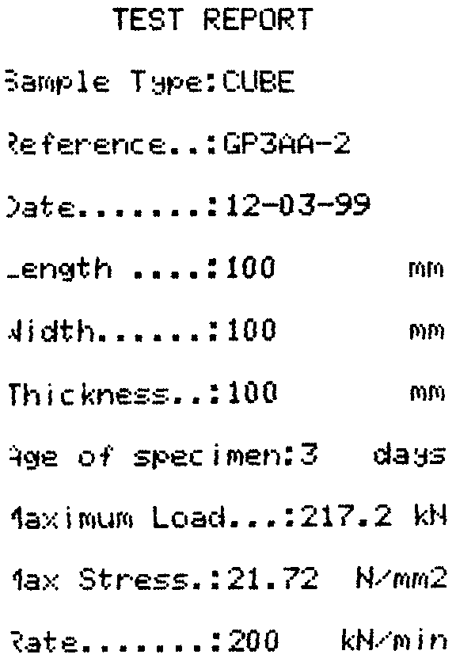
Day 3 (12 March 99)
Day 7 (17 March 99)

