The National University of Singapore
Faculty of Engineering


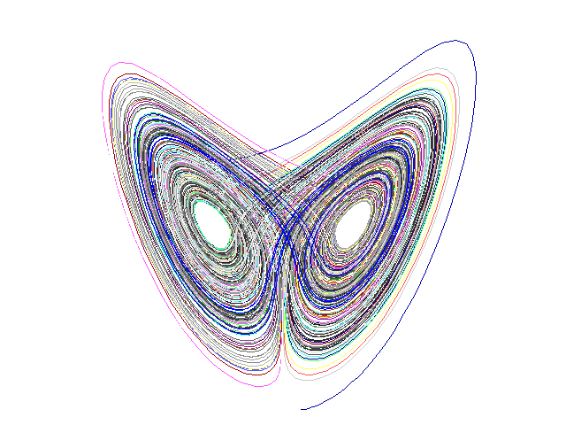

PC 1324 Taming Chaos
Term Paper

Tan Wee Siang

985804M11
Department of Civil Engineering
Year 2 99/00
goodwill@letterbox.com
16 October 1999
"We are at an important turning point in the history of science.
We have come to the end of the road paved by Galileo and Newton,
which presented us with an image of a time-reversible, deterministic universe.
We now see the erosion of determinism
and the emergence of a new formulation of the laws of physics.
The future is no longer a given."
Ilya Prigogine
References

Books

Lecture Notes
Dr Christopher Ting
1999

"Encounters With Chaos"
Denny Gulick
McGraw-Hill Inc., Singapore
1992

"How Nature Works"
Per Bak
Opernicus, New York
1996

"Introduction: Control and Synchronization of Chaos"
William L. Ditto & Kenneth Showalter
Chaos, Vol. 7, No. 4
1997

"The End of Certainty"
Ilya Prigogine
The Free Press, New York
1996

"The Essence of Chaos"
Edward N. Lorenz
University of Washington Press, Seattle
1993

"The Nature of Chaos"
Tom Mullin, etc
Oxford Science Publications, New York
1994
Websites

"Bringing It Down to Earth"
Michelle Jacobs
http://www.astrologer.com/chaology/earth.html/
1995

"Chaos & Global Warming"
Peter Swanson, etc
http://forum.swarthmore.edu/epigone/sci.math/jartekhee/pjswan-ya023180000107971612220001@melsun0.mel.go.jp/
1997

"Chaos Could Hold Key to BC Weather"
Gavin Wilson
http://publicaffairs.ubc.ca/reports/no14/weather.html/
1996

"Dr. Edward N. Lorenz Applies Chaos Theory to Atmospheric Science"
Hannah M. Fairfield
http://www.ldeo.columbia.edu/press_releases/lorenz/lorenz2.html/
1998

"Making Order Out of Chaos"
Andrew Davenport, Shane Kraynak & Brian Timko
http://tqd.advanced.org/12170/history/lorenz.html/
1997

"Weather Prediction is Chaos Theory in Action - And What Chaos!"
Marian MacNair
http://www.exn.ca/html/templates/htmlpage.cfm?ID=19970320-03/
1997

